Case Study Report



**Tech Saksham**

Data Analytics with Power BI

**INVENTORY AND SALES ANALYSIS OF DEPARTMENTAL STORE**

**SRI KRISHNA ADITHYA COLLEGE OF ARTS AND SCIENCE**

|  |  |
| --- | --- |
| **NM ID** | **NAME** |
| A4B617FB85BBF9DABC54BF1C591852FE | VIVIN RICHARD G |

|  |  |
| --- | --- |
| Trainer Name: R . UMAMAHESWARI  Master Trainer: R . UMAMAHESWARI |  |
|  |  |
|  |  |

**ABSTRACT**

Effective inventory and sales analysis play a crucial role in the success of departmental stores in the retail sector. The project titled "Inventory and Sales Analysis of Departmental Store" utilizes PowerBI to explore the complexities of managing inventory and understanding sales patterns. By utilizing up-to-date data collected during transactions, this analysis offers valuable information on how products are performing, how quickly inventory is being sold, and how revenue is being generated. Stakeholders can access interactive displays and detailed reports, enabling them to make informed decisions to improve inventory management, identify best-selling items, and boost profitability.

**INDEX**

|  |  |  |
| --- | --- | --- |
| **Sr. No.** | **Table of Contents** | **Page No.** |
| 1 | Chapter 1: Introduction | 1 |
| 2 | Chapter 2: Services and Tools Required | 4 |
| 3 | Chapter 3: Project Architecture | 6 |
| 4 | Chapter 4: Modeling and Result | 7 |
| 5 | Conclusion | 9 |
| 6 | Future Scope | 10 |
| 7 | References | 11 |
| 8 | Links | 12 |

**CHAPTER 1**

**INTRODUCTION**

* 1. **Problem Statement**

Department stores encounter obstacles in efficiently managing inventory and analyzing sales data because of outdated manual approaches. These methods are time-consuming, lack immediate insights, and result in ineffective stock control, missed sales chances, and less-than-optimal profitability. The intricacies of overseeing inventory across various divisions and locations add further complexity. Real-time assessment of sales data proves critical for recognizing patterns and tackling potential issues. Over-reliance on past data can restrict potential insights. Technological progressions offer remedies like AI and machine learning-fueled integrated inventory management systems, delivering instant clarity on stock levels, demand predictions, and inventory efficiency. These solutions can unveil latent trends and predict sales patterns. Incorporating cloud-based platforms and mobile apps boosts operational effectiveness.

* 1. **Proposed Solution**

The suggested solution utilizes Microsoft Power BI to modernize inventory control and sales analysis procedures within departmental stores. Power BI, a powerful tool for data visualization and analytics, converts unprocessed data into practical insights. It links with current point-of-sale systems to amalgamate real-time data concerning sales transactions, available inventory, and customer engagements. Through interactive reports and dashboards, Power BI offers a detailed synopsis of essential metrics. Store managers can rely on these dashboards to oversee inventory levels, pinpoint high-selling items, and predict situations of excess or shortage. Power BI's sophisticated analytics support predictive modeling, forecasting, inventory management, procurement choices, and interdepartmental coordination, facilitating business development and expansion strategies.

* 1. **Feature**
* Real-Time Inventory Analysis
* Sales Trend Analysis
* Product Performance Metrics
* Inventory Turnover Ratios
  1. **Advantages**

**Enhanced Inventory Management:**

* Departmental stores utilize automated systems, demand forecasting, just-in-time practices, and dynamic replenishment processes for improved inventory management, reducing manual errors and stockouts.

**Improved Sales Forecasting:**

* Improved sales forecasting utilizes data analytics and predictive modeling to predict future sales performance, integrating data from various sources and conducting scenario analysis for informed retailers.

**Optimal Stock Levels:**

* Inventory optimization techniques, dynamic management, and collaborative planning ensure optimal stock levels, meet customer demand, minimize costs, avoid stockouts, and reduce lead times through real-time adjustments.

**Increased Profitability:**

* Effective inventory management and sales forecasting strategies enhance profitability by reducing costs, optimizing revenue, and enhancing customer satisfaction, leading to lower carrying costs and improved margins.
  1. **Scope**

With the use of PowerBI dashboards and reports, this project seeks to enhance department store inventory management and sales analysis procedures. The project collects, examines, and visualizes sales and inventory data using PowerBI, offering both historical and current insights. Store managers, inventory controllers, and executives need this information in order to make well-informed decisions regarding pricing policies, promotional campaigns, and inventory replenishment. Additionally, the initiative establishes the foundation for upcoming improvements, such as sophisticated inventory optimization methods and predictive analytics. These tools have the ability to predict demand trends, spot possible hazards, and modify pricing and inventory levels. The project's goal is to provide all stakeholders the opportunity to make data-driven decisions, which will increase operational effectiveness, increase profitability, and guarantee the retail sector's long-term prosperity.

**CHAPTER 2**

**SERVICES AND TOOLS REQUIRED**

**2.1 Services Used**

* **Data Collection and Storage Services:** Modern information systems rely on data collection and storage services for efficient data management, including source identification, transformation, real-time ingestion, database systems, data warehousing, and interoperability.
* **Real-Time Data Processing Services:** Real-time data processing services, utilizing technologies like Apache Kafka and Amazon Kinesis, are crucial for businesses to stay competitive in the digital landscape.

**Top of Form**

* **Data Visualization Services:** Data visualization services are essential for organizations to visually represent raw data, aiding in understanding patterns and effectively communicating complex information.

**2.2 Tools and Software used**

1. **Power BI**: Microsoft created the Power BI package of business analytics tools, which allows users to display and analyze data. Connecting to several data sources, transforming data, producing interactive reports and visualizations, and disseminating insights throughout the company are all made possible by it. Because of its user-friendly design, Power BI is available to both data specialists and business users.
2. **Power Query**: Power Query is a tool for connecting data that lets users find, join, aggregate, and clean up data from many different sources. Numerous Microsoft products, like as Excel and Power BI, have it integrated. Users may quickly import data from databases, files, webpages, and other sources, process the data, put it into their analysis environment, and carry out data transformations and purification tasks using Power Query.
3. **Power BI Desktop**: The main writing tool for Power BI reports and dashboards is a free desktop program called Power BI Desktop. It offers an extensive feature set for report design, data modeling, and visualization. With a drag-and-drop interface, users can develop interactive visualizations, establish links between tables, connect to numerous data sources, and publish their reports to the Power BI Service.
4. **Power BI Service**: Microsoft offers Power BI Service, commonly referred to as Power BI online, as a cloud-based platform for managing, sharing, and working together on Power BI content. Users can publish Power BI dashboards and reports to the cloud, where they can be accessed by external parties or by other members of their business (if set). Access authorization management, data refresh scheduling, data-driven alert setup, and online report viewing are all made possible by Power BI Service.
5. **Power BI Mobile**: Power BI Mobile is a collection of mobile apps for Windows, iOS, and Android smartphones that increase the accessibility of Power BI content for users who are always on the go. Users using Power BI Mobile may view interactive visualizations, explore data, and receive data-driven alerts and notifications in addition to being able to access their Power BI reports and dashboards from smartphones and tablets. The mobile apps offer a dynamic user experience for viewing and engaging with Power BI content on mobile devices and are geared for touch interactions.

**CHAPTER 3**

**PROJECT ARCHITECTURE**

**3.1 Architecture**

**USER FRONTEND BACKEND**

|  |  |  |
| --- | --- | --- |
|  | **HTML 5** | **NODEJS 14.0**  **Database** |

Here’s a high-level architecture for the project:

1. **Data Collection:** Transactional data from sales, inventory, and other relevant sources within the departmental store is collected in real-time. This includes data from barcode scanners, POS systems, and inventory management systems.
2. **Data Storage:** The collected data is stored in a database for processing and analysis. Azure SQL Database or AWS RDS can be utilized for this purpose, ensuring efficient storage and retrieval of data.
3. **Data Processing:** Real-time data processing is performed using Power BI's built-in capabilities or additional services like Azure Stream Analytics or AWS Kinesis Data Analytics. This involves cleaning, transforming, and aggregating the data to derive meaningful insights.
4. **Data Modeling:** Machine learning algorithms may be applied to the processed data to predict sales trends, identify patterns, and optimize inventory management. This could involve tools like Azure Machine Learning or custom algorithms developed using Python or R.
5. **Data Visualization**: Power BI is used to create interactive dashboards and reports that visualize the analyzed data. This includes sales performance metrics, inventory levels, trend analysis, and customer segmentation.
6. **Data Access:** The Power BI dashboards and reports can be accessed through various platforms including Power BI Desktop, Power BI Service (online), and Power BI Mobile app. This enables stakeholders to view and interact with the analysis results in real-time.

This architecture provides a comprehensive solution for inventory and sales analysis, enabling the departmental store to make data-driven decisions and optimize operations. However, it's important to customize the architecture based on specific requirements, existing infrastructure, and compliance with data privacy regulations.

**CHAPTER 4**

**MODELING AND RESULT**

**Manage relationship**

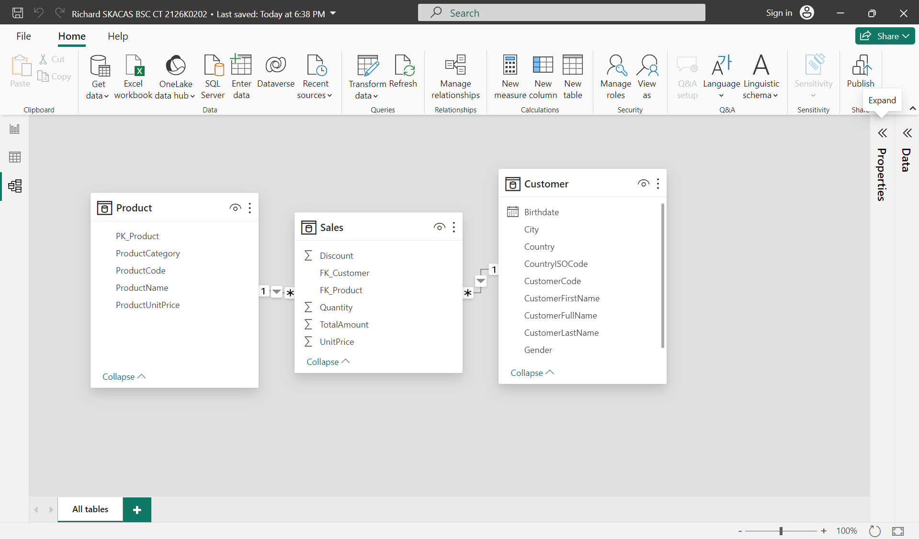

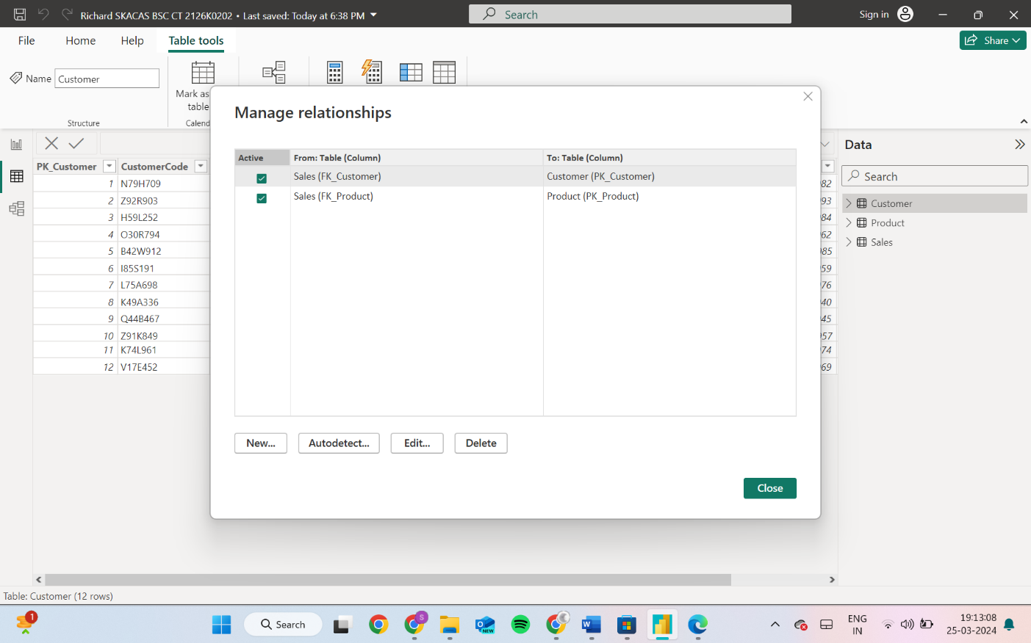

**EDIT RELATIONSHIP:**

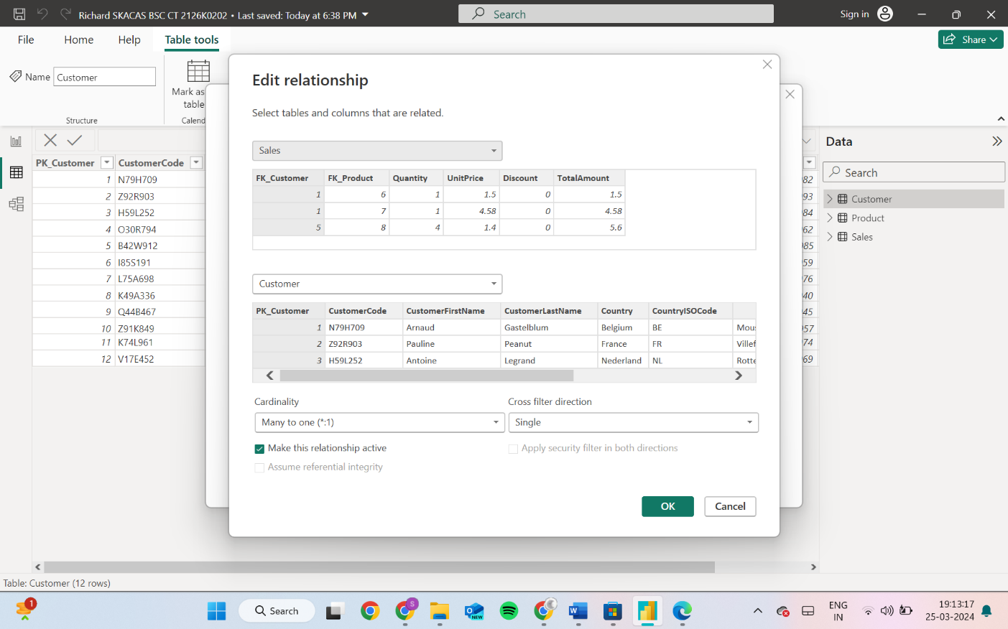

**Dashboard**

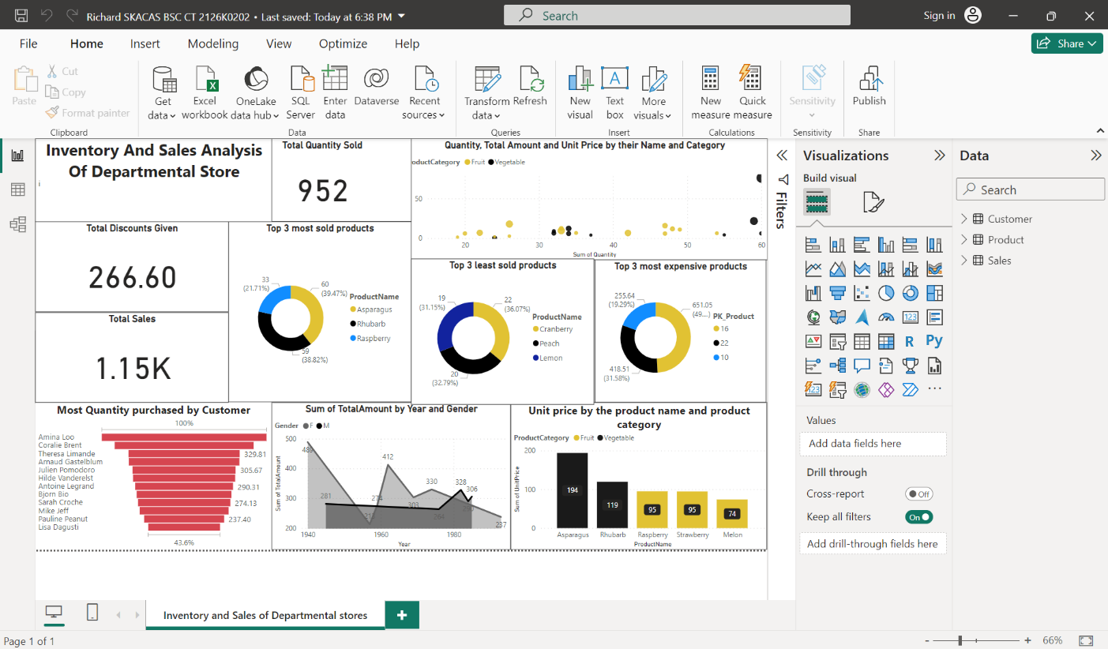

**CONCLUSION**

The project “Real-Time Analysis of Bank Customers” using PowerBI has successfully demonstrated the potential of data analytics in the banking sector. The real-time analysis of customer data has provided valuable insights into customer behavior, preferences, and trends, thereby facilitating informed decision-making. The interactive dashboards and reports have offered a comprehensive view of customer data, enabling the identification of patterns and correlations. This has not only improved the efficiency of data analysis but also enhanced the bank’s ability to provide personalized services to its customers. The project has also highlighted the importance of data visualization in making complex data more understandable and accessible. The use of PowerBI has made it possible to present data in a visually appealing and easy-to-understand format, thereby aiding in better decision-making.

**FUTURE SCOPE**

The project aims to enhance inventory management and sales analysis in departmental stores by integrating advanced technologies and methodologies. This includes an increase in predictive analytics capabilities, which will enable proactive decision-making and resource allocation. Machine learning methodologies will be used to continuously refine predictive models and adapt to market dynamics. Advanced inventory optimization techniques will optimize inventory levels, procurement costs, and customer demand, maximizing profitability while minimizing wastage. The integration of IoT devices and AI will provide real-time data on inventory levels, shelf life, and environmental conditions, allowing for better visibility and control. AI-driven analytics will provide actionable insights, enhancing operational efficiency and customer satisfaction.

**REFERENCES**

* "Retail Analytics: The Secret Weapon" by Emmett Cox - This book provides insights into the importance of analytics in the retail industry, including inventory management, sales analysis, and customer behavior tracking.
* "The Data Warehouse Toolkit: The Definitive Guide to Dimensional Modeling" by Ralph Kimball and Margy Ross - This classic book offers comprehensive guidance on building data warehouses and dimensional modeling, which are essential for conducting effective inventory and sales analysis.
* "Sales Analysis Techniques: Using Excel and Power BI" by Matt Allington - This practical guide demonstrates how to perform sales analysis using Excel and Power BI, with step-by-step instructions and real-world examples.
* "Power BI Essentials: An End-to-End Guide to Understanding Power BI" by Mynda Treacy and Matt Allington - For a deeper understanding of Power BI and its application in retail analytics, this book offers comprehensive coverage of Power BI features and functionalities

**LINK**

https://github.com/vivin080602/INVENTORY-AND-SALES-ANALYSIS-OF-DEPARTMENTAL-STORE.git